18s rDNA characterization and morphological investigation of the medicinal leech Hirudo medicinalis from Felaw Pond

Running title: 18s rDNA of Hirudo medicinalis.

Danial Kahrizi¹, Samir Jawdat Bilal^{2*}
¹ Agricultural Biotechnology Department, Faculty of Agriculture, Tarbiat Modares University, Tehran, Iran
² Department of Fish Resource and Aquatic Animals, College of Agriculture Engineering Sciences, Salahaddin University-Erbil, Erbil, Iraq
*Corresponding author. Email: samir.bilal@su.edu.krd

ABSTRACT
Hirudinea leeches are obligate parasites on a variety of vertebrates and have recently gained attention for their medicinal purposes. The present study aimed to improve the presence of Hirudo medicinalis in Kurdistan and Iraq (especially because it is regarded as a native species in this region). A total of 23 leech specimens were collected from Felaw Pond during January-July 2023. The collected specimens were investigated morphologically and their species were confirmed according to their partial sequence of 18s rDNA. Primers used were universal, C1 (ACCCGCTGAATTTAAGCAT) (forward primer), and C3 (CTCTTCAGAGTACTTTTCAAC) (reverse primer). The results of the morphological study and molecular sequencing of partial 18s rDNA demonstrated that all these leech specimens belonged to Hirudo medicinalis with an abundance of 0.13 leech/ m². The present record was the first one investigating this species in Iraq.
Keywords: 18s rDNA, Felaw, Hirudo medicinalis, Morphology

1. Introduction
The genus Hirudo can be regarded as the most famous and known in the Hirudinidae family since they are applied widely for medicinal purposes [1]. Among all known medicinal leech species, the European medicinal leech Hirudo medicinalis holds the title of being the most renowned and important [1,2]. For a long time, it has been recognized as the only valid species in this genus. However, according to more detailed studies from the ordinary morphological studies supported by molecular characterizations, the genus Hirudo currently represents six species, namely H. medicinalis (in central Europe, British Isles, Southern parts of Scandinavia, and various places in Russia), H. verbana (in Italy, Peninsula Balkan, and Eastward basin of the Caspian Sea), H. orientalis (in the Transcaucasian Countries, Iran, and Central Asia), H. troctina (in Northwestern Africa and Spain), H. nipponia (in East Asia, including Japan), and H. sulukii (in Turkey) [1-4]. According to Trontelj and Utevsky [1] and Silverstein [5], H. medicinalis is the most distributed Mediterranean species in the West Palaearctic region and Turkey, hence its presence in Iraq is highly probable especially because most water bodies and mountains are shared between these two countries.
Hirudinea leeches are obligate parasites on a variety of vertebrates and have recently gained attention for their medicinal purposes; as a result, their medicinal application is well-developed and accelerated. For centuries, H. medicinalis and related species were prescribed to treat virtually human arthritis and other diseases (e.g., yellow fever) [3].
The present study aimed to improve the presence of H. medicinalis in Kurdistan and Iraq (especially because it is regarded as a native species in this region) in addition to another species H. verbena, which was recorded previously by Hallaq [6] in a different area of Kurdistan Region. Finally, the study improved the first report of H. medicinalis in Iraq based on the morphological and molecular characteristics of the collected specimens as the second species of the genus recorded in Iraq.

2. Materials and methods
Specimens of large-sized leeches were recorded from the cold waters of Felaw Pond and other nearby small ponds from January to July 2023. Felaw Pond is located on the fringe of the Halgurd-Sakran Mountains near the Choman District in the Balakayati area close to the Iranian border, 1,800 meters above sea level, about 160 Km north of Erbil, Latitude 36.62094° or 36° 37' 15" north and Longitude 44° 55' 44" east [7].
For morphological examination, the collected leech specimens were transferred as live with pond water to the lab. They relaxed by being placed in small to medium jars filled with distilled water, and dropwise additions of 10% ethanol were used until the leech did not respond to the touch. During the next 40-60 min, the leeches became limp and would not respond to touch. The extended length and diameter were measured, color patterns recorded (photos of live specimens were taken with a Canon camera), clitella and gonopores position detected, number of eyes counted, the shape of suckers recorded, and then each specimen enumerated [6, 8, 9]. Leeches were fixed by gently being pressed up to nearly flat (between two glass slides), and after total relaxation, they were fixed in 10% buffered formalin (for at least 3 h and large specimens were left for 24 h) and preserved in 70% ethanol [6, 10, 11]. Photographs were taken with a Canon camera (Open Box Canon Power Shot ELPH 180 camera, 8x Optical Zoom, 20.0 Megapixel), and drawings were made with a Lucida tube attached to an ocular micrometer. Leeches were identified according to Kovalenko and Utevsky [12], and Kutschera and Elliott [13].
For molecular study, for DNA extraction, Genomic DNA from Hirudo samples was obtained by employing PureLinkTM Genomic DNA Mini kit of extraction (Thermofisher, USA) according to the manufacturer's instruction with few modifications (incubation time of tissue lyses step was extended into 4 h and absolute ethanol was utilized instead of isopropanol for DNA precipitation). The samples were macerated in mortar and pestle, and the contents were transferred into a sterile tube containing 200 μl tissue lysis buffer and kept in an incubator for 4 h. Qualification and quantification of DNA concentration were performed using OneDrope TOUCH (Biometrics, Taiwan). Samples of DNA genomic with (A260-A320) / (A280-A320) ratio of more than 1.7 µg and outputs of more than 0.7 µg were obtained.
2.1. DNA Amplification and Sequencing
A region of 18S rDNA was amplified by polymerase chain reaction (PCR). The primers were universal, forward primer C1 (ACCCGCTGAATTTAAGCAT), and reverse primer C3 (CTCTTCAGAGTACTTTTCAAC), which were designed and selected by Apakupakul et al. (1999). PCR reaction and condition were performed using SimpliAmp, Applied Biosystem (AB) thermal cycler. A volume of 50 μl reaction mixture was prepared in PCR tubes containing 3 μl DNA template, 25 μl red master mix (AmpliTaq III, Danemark), 1 μl for each primer, and 20 μl double demonized water (ddH₂O). The cycling conditions were as follows: 94°C for 5 min (initial denaturation), 35 cycles of denaturation at 94°C for 45 s, annealing temperatures at 51°C for 45 s and extension at 72°C for 45 s, and 72°C for 5 min (final extension). Agarose gel electrophoresis was employed to check the efficiency of PCR reactions. The samples were prepared and run in 2% gel of agarose, and then stained with ethidium bromide that makes the DNA visible under UV light, with the expected size of the PCR product at 565 bps. In the present study, a SeqStudio genetic analyzer (ABI, USA) was used to find the nucleotide order of 18S rDNA in the sample. The PCR fragments of the sample were removed from the agarose gel and used as a source of DNA template for the sequence-specific PCR amplification.
2.2. Statistical analysis
Accumulation and leech density were calculated following the quadrant method (15 quadrants in each month). The quadrat equation used in the present study for population density calculation was according to Goldstein and Srivastava (2022).

3. Results
In the present study, a total of 23 leech specimens were collected from the Felaw Pond and on the shore's wet stones, lower side of emerged debris and plate surfaces with an abundance of 0.13 leech/m². The morphological investigation as well as the molecular examination of partial 18s rDNA locus showed that all collected specimens belonged to the European medicinal leech H. medicinalis (Figure 1A, B, C, D; 2).
The maximum length was estimated at 123.21-126.62 mm (fully extended) and the minimum length at 49.93-60.05 mm (relaxed). Body width was calculated at 9.72-9.92 mm. The buccal cavity-armed muscular ridges were surrounded by cuticular teeth. The mouth was a wide aperture, while the oral (anterior) sucker was small in comparison to the mouth (Figure 1B). The pharynx was median in length followed by the crop, which was highly distinctive in this species. Oral sucker and posterior sucker dimensions were 5.12-5.68 mm and 6.27-6.83 mm, respectively. Leech specimens showed five pairs of eyes located on their front end (arranged in a parabolic arc) (Figure 1A, C). Specimens' dorsal sides were shiny dark brown (blackish), with six longitudinal dark red to brownish stripes (with connected spot likes on each annulus) (Fig. 1A), and the ventral surface was speckled, greenish with black spots (Figure 1B). Considering the clitellum region (lightened coloration flourishing during copulation season), the male gonopore was on XIb5, there were two internal ducts leading to it; however, these united to form a single genital atrium, whereas the female gonopore was posterior to the male pore, median, unpaired situated on XIIb5 (Figure 1 C).
The color pattern was distinct with a unicolor olive greenish ventral side speckled with black spots, while on the dorsal side dark brown to black (blackish dots) and two dark red colored longitudinal lateral stripes were observed. Black oval spots were present in the para-marginal part that was diffused and arranged segmentally; this coloration pattern is a typical one of H. medicinalis (Figure 1 A, B) [14–16].
In the molecular-based identification, the sequence from DNA of H. medicinalis was 18S rDNA of 528 bp (amplified fragment was 610 bp, while after sequencing, few miss-nucleotides were excluded, which were related to the quality of sequencing analysis) that was put to BLAST and then compared with other stored species of Hirudo sequences from GenBank. The BLAST results indicated that the query sequence was 100% identical to H. medicinalis (Figure 2) with a sequence ID AY786464.1.

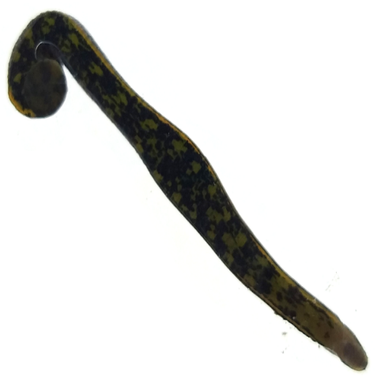
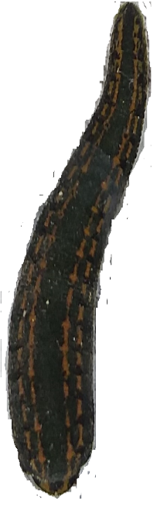
A
B
C
D
e
mg
fg

Figure 1. Photomicrograph of Hirudo medicinalis. A: Whole body, dorsal surface. B: Whole body, Ventral view. C: Anterior End. D: Clitella region. Where, e= eye spot, fg= female gonopore, mg= male gonopore

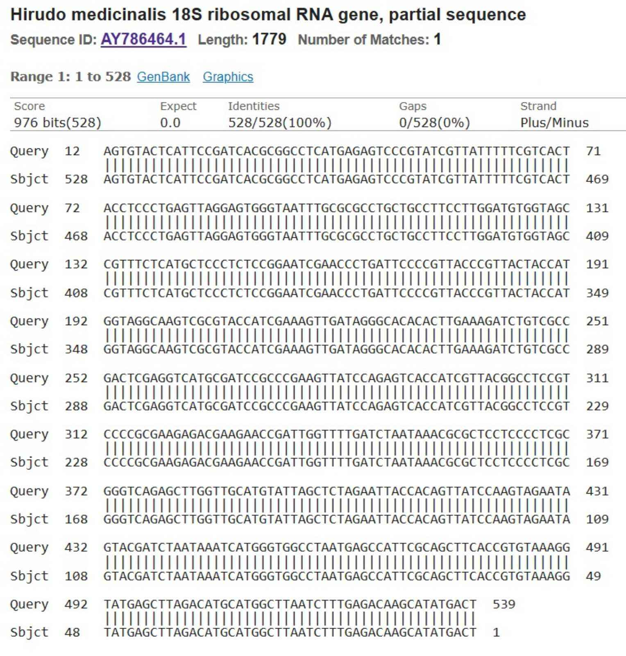
Figure 2. Pairwise alignment of 18S rDNA sequence of Hirudo medicinalis. Query is the study or sample sequence and Subject is the GenBank sequence.

4. Discussion
The genus Hirudo can be regarded as the most famous and known in the Hirudinidae family since they are applied for medicinal purposes. The ordinary European medicinal leech, H. medicinalis, is the first described species in the genus Hirudo, followed by other species, including H. nipponia, H. orientalis, H. sulukii, H. troctina, and H. verbena, been recognized as valid species according to more detailed studies [2, 4, 5, 17].
The results of morphological characteristics and the measurements of the present specimens were the same as those reported by [14]. Kutschera and Elliott [13], and Silverstein . Moreover, the present characteristics were compared to those recorded by Hallaq [6] for H. verbena. The results of the last mentioned were consistent with those described by Gerry and Ellerby [18], who studied the morphology of H. verbana specimens. Cséfalvay et al. [19] compared H. medicinalis with H. verbena, and their records for the latter were in agreement with that of the present study. What specifically distinguishes H. medicinalis from another morphologically similar species, H. verbana [13], are the five pairs of eyespots and sensory papillae arrangement (Figure 1A).
The findings of the molecular investigation were highly similar to those reported by other researchers [16, 20–22]. The BLAST results of the present study showed 100% similarity with those of rDNA from Gene Bank.
The recent distinction among the species relies on molecular characterizations; nevertheless, further investigations are required to clarify the real distribution of species [3, 17, 23, 24].
H. medicinalis is a riparian semi-aquatic leech (can be found on shores of rivers, streams, ponds, and marshes). This species is a real hematophagous parasite actively searching for the host by moving the body in a wave-like motion which propels it forward in the water; it is found mainly in cold to semi-warm water (no active specimens were seen in water temperatures lower than 10°C) [16, 17, 22].
H. medicinalis is the most distributed Mediterranean species in the Western Palaearctic and Turkey [25], while Solgi et al. [16] regarded it as the second most distributed species after H. verbana in Iran, hence it can be regarded as a native species in Iraq. This species has even been regarded as a neglected species by Utevsky et al. [23] in the Western Palaearctic region. Kutschera and Elliott [13] studied the morphology and occurrence of the European medicinal leech H. medicinalis and regarded it as an endangered species [4] considered it under extinction risk in Romania because of its pollution, restricted proper habitat area, and overhunting for medicinal purposes. These findings were in line with those of the present study since the measured abundance was 0.13 leech/ m², especially if the pollution around the pond is regarded because of the presence of tourists. Farzali and Sağlam [17] examined the distribution of Hirudo species in Bulgaria and reported the presence of both species' populations, H. medicinalis and H. verbena, together in some localities, which was in agreement with the presence of both species in Kurdistan, Iraq.
Trontelj et al. [20] revealed that the genetic differentiation of two medicinal leech species, H. medicinalis and H. verbena, depended on the random amplified polymorphic DNA.
Won et al. [21] conducted conventional PCR using nuclear 18S rRNA and mitochondrial cytochrome c oxidase subunit 1 (CO1) as genetic markers for some collected leech specimens from Korea. In the mentioned study, the results of 18S rRNA sequences showed 99.9% identity with Haemadipsa rjukjuana and the CO1 sequences made the leeches very close to H. rjukjuana.
5. Conclusion
To the best of our knowledge, no reports of the present species have been found in the review of the previous studies in Iraq; hence, the present research can be regarded as the first one dedicated to Hirudo medicinalis in Iraq.

Conflict of Interests
The author has no conflicts with any step of the article preparation.
Consent for publications
The author read and approved the final manuscript for publication.
Ethics approval and consent to participate
No human or animals were used in the present research.
Informed Consent
The authors declare that no patients were used in this study.
Availability of data and material
The data that support the findings of this study are available from the corresponding author upon reasonable request
Authors' contributions
Danial Kahrizi: Research design and supervision; Samir. J. Bilal: Perform all laboratory procedures
Funding
None

References
1. Trontelj P, Utevsky SY (2012) Phylogeny and phylogeography of medicinal leeches (genus Hirudo): Fast dispersal and shallow genetic structure. Mol Phylogenet Evol 63:475–485. doi: 10.1016/j.ympev.2012.01.022
2. Kovalenko MV. Utevsky SY (2013) Transitional morphology in hybrids of Hirudo verbana and H. orientalis (clitellata, hirudinida). Vestn Zool doi: 10.2478/vzoo-2013-0057
3. Saglam N, Saunders R, Lang SA, Shain DH (2016) A new species of Hirudo (Annelida: Hirudinidae): historical biogeography of Eurasian medicinal leeches. BMC Zool 1:1–12. doi: 10.1186/s40850-016-0002-x
4. Surugiu V (2018) On the presence of the European medicinal Leech Hirudo medicinalis Linnaeus, 1758 (Annelida: Hirudinea) in Romania. Trav du Museum Natl d’Histoire Nat Grigore Antipa 61:7–11. doi: 10.2478/travmu-2018-0002
5. Silverstein, K. (2023) "Hirudo medicinalis" (On-line), Web. Accessed January 24, 2024 at https://animaldiversity.org/accounts/Hirudo_medicinalis/
6. Atkauskien I, Rutkauskait-Sucilien J (2022) The present state of the leech fauna (Annelida: Hirudinea) in Lithuania. Zootaxa 5115(1):47-62. doi: 10.11646/zootaxa.5115.1.3
7. Abdulla F, Al-badranih L (2000) Application of a rainfall-runoff model to three catchments in Iraq. Hydrol Sci J 45:13–25. doi: 10.1080/02626660009492303
8. Ahmed ST (2009) Biological studies on leeches in Erbil and its suburbs (Doctoral dissertation, Ph. D. Thesis, Coll. Sci., Univ. Salahaddin: 113pp).
9. Iwama RE, Arruda EP (2016) Leeches of the genus Helobdella (Clitellata: Hirudinida) from São Paulo, Brazil with descriptions of two new species using micro-computed tomography and a new record of Barbronia weberi (Blanchard 1897). Zootaxa 4144:411–429. doi: 10.11646/zootaxa.4144.3.8
10. Hovingh P (2006) The leech Haemopis lateromaculata (Hirudinea: Haemopidae): Its North America distribution and additional notes on species description. Can Field-Naturalist 120:443–451. doi: 10.22621/cfn.v120i4.353
11. Kutschera U, S Shain D (2019) Hirudinea Lamarck 1818: Evolutionary origin and taxonomy of the six medicinal leeches (genus Hirudo) known today. Biomed Res Rev 3:1–4. doi: 10.15761/brr.1000126
12. Kovalenko M V., Utevsky SY (2012) Size structures and comparative phenology of syntopic populations of Hirudo verbana and Hirudo medicinalis in eastern Ukraine. Biologia (Bratisl) 67:934–938. doi: 10.2478/s11756-012-0089-7
13. Kutschera U, Elliott JM (2014) The European medicinal leech Hirudo medicinalis L.: Morphology and occurrence of an endangered species. Zoosystematics Evol 90:271–280. doi: 10.3897/zse.90.8715
14. Davies RW (1971) A Key to the Freshwater Hirudinoidea of Canada. J Fish Res Board Canada 28:543–552. doi: 10.1139/f71-077
15. Todorov M, Grozeva S, Hubenov Z, Kenderov L, Trichkova T (2016) Taxonomic status and distribution of medicinal leeches of the genus Hirudo L. (Hirudinea) in Bulgaria. Acta Zool Bulg 68:171–182.
16. Solgi R, Raz A, Zakeri S, Tavakoli Kareshk A, Yousef A, Jarehan A, et al (2021) Morphological and molecular description of parasitic leeches (Annelida: Hirudinea) isolated from rice field of Bandar Anzali, North of Iran. Gene Rep 23:101162. doi: 10.1016/j.genrep.2021.101162
17. Farzali S, Sağlam N (2022) The distribution, economic importance and status of medical leech (hirudo orientalis) in the azerbaijan. Nwsa Acad J 17:112–123. doi: 10.12739/nwsa.2022.17.3.5a0170
18. Gerry SP, Ellerby DJ (2011) Serotonin modulates muscle function in the medicinal leech Hirudo verbana. Biol Lett 7:885–888. doi: 10.1098/rsbl.2011.0303
19. Cséfalvay R, Janák M, Immerová B (2017) First reliable records of Hirudo verbana Carena, 1820 (Annelida: Hirudinida) from Slovakia and notes on its syntopy with Hirudo medicinalis Linnaeus, 1758. Folia Faun Slovaca 22:63–66.
20. Trontelj P, Sotler M, Verovnik R (2004) Genetic differentiation between two species of the medicinal leech, Hirudo medicinalis and the neglected H. verbana, based on random-amplified polymorphic DNA. Parasitol Res 94:118–124. doi: 10.1007/s00436-004-1181-x
21. Won S, Park BK, Kim BJ, Kim HW, Kang JG, Park TS, et al (2014) Molecular identification of Haemadipsa rjukjuana (Hirudiniformes: Haemadipsidae) in Gageo Island, Korea. Korean J Parasitol 52:169–175. doi: 10.3347/kjp.2014.52.2.169
22. Živić I, Radosavljević T, Stojanović K, Petrović A (2015) The first molecular characterization of the genus Hirudo on the territory of Serbia: estimation of endangerment. Aquat Ecol 49:81–90. doi: 10.1007/s10452-015-9506-7
23. Utevsky S, Zagmajster M, Atemasov A, Zinenko O, Utevska O, Utevsky A, et al (2010) Distribution and status of medicinal leeches (genus Hirudo) in the western palaearctic: Anthropogenic, ecological, or historical effects? Aquat Conserv Mar Freshw Ecosyst 20:198–210. doi: 10.1002/aqc.1071
24. Minelli A, Rovelli V, ZapparolI M, Bologna M. (2016) Hirudo verbana Carena, 1820 (Sanguisuga). In: Stoch F., Genovesi P. (ed.), Manuali per il monitoraggio di specie e habitat di interesse comunitario (Direttiva 92/43/CEE) in Italia: specie animali. ISPRA, Ser Manuali e Linee Guid 189.
25. Marrone F, Canale DE (2019) Occurrence, distribution and bibliography of the medicinal leech Hirudo verbana Carena, 1820 (Hirudinea, Hirudinidae) in Sicily (Italy). Biogeographia 34:33–38. doi: 10.21426/B634143807

